

SUMMER EXAMINATIONS 2022

**EXAMINATION:** **UNIT** **1** **Fundamentals** **of** **Packaging** **Technology** **and** **Packaging** **in** **the** **Supply** **Chain**

**COURSE:** **CPD** **Diploma** **in** **Packaging** **Technology**

**DATE:** **12th** **May** **2022**

**10am** **to** **12pm**

**EXAMINERS:** **Tony** **Duffy,** **David** **Little** **TIME** **ALLOWED:** **2** **hours**

**INSTRUCTIONS:** **Please** **answer** **four** **questions.** **All** **questions** **carry** **equal** **marks**

**PLEASE** **DO** **NOT** **TURN** **OVER** **THIS** **PAGE** **UNTIL** **YOU** **ARE** **INSTRUCTED** **TO** **DO** **SO**

The use of programmable or text storing calculators, smart phones etc are expressly forbidden. Please note that where a candidate answers more than the required number of questions, the examiner will mark all questions attempted and then select the highest scoring ones.

1. The definition of packaging encompasses three general aspects. Discuss these three aspects and their importance to a finished packed product.

# (10 marks)

1. Choose three of the following and state whether the following statements are True or False and briefly explain why.
   1. Recycling is placing packaging material in your green bin.
   2. Recycled material is economical.
   3. We should recycle everything.
   4. Incineration is environmentally unsound.

**(3** **x** **5** **marks)**

**Question** **2** **(25** **marks)**

1. Compare and contrast the difference in the supply chain hazards experienced if one is distributing an FMCG product to a multiple, compared to the delivery of an on-line order of one item to someone’s home.

# (10 marks)

1. The Hazards of Distribution can have a major effect on packaging and product damage. Discuss five of the general impacts, experienced by packaging in the Supply Chain.

**(15** **marks)**

**Question** **3** **(25** **marks)**

1. Discuss how vibration can be measured and processed.

# (9 marks)

1. Describe what the natural frequency is and its importance in causing vibration damage in distribution.

# (5 marks)

1. Shock from drops can be measured with an accelerometer. Discuss how the shock pulse can be analysed with the aid of the damage boundary curve to determine if the shock is likely to have caused damage.

# (7 marks)

1. Briefly describe the factors which will impact on the frequency and intensity of shock which a pack will experience in distribution.

# (4 marks)

1. A computer specification states that the product has a fragility of 50G. Explain what this means and describe how a packaging engineer should use this information in designing the distribution packaging.

# (4 marks)

1. The concept of an ideal cushion material can be used to design appropriate cushioning. Discuss the characteristics of an ideal cushioning material.

# (6 marks)

1. A laptop weighs 1.5 kg. It is estimated that it has a fragility of 100G. The manufacturer wants to protect this product from falls of up to 2 m during distribution using expanded polystyrene. Product data states that the expanded polystyrene has a cushioning factor of 3.1 and has a maximum static stress of 13.7 kPa.

Calculate the thickness and the area of cushioning required.

# (6 marks)

1. A pack falls from 1 m hits the ground and rebounds 250 mm. Calculate the impact velocity, the rebound velocity, and the coefficient of restitution.

# (9 marks)

**Note:**

t = Ch/G

*Where*

t is Cushion thickness C is cushion factor

h is drop height

G is fragility factor V2 = U2 + 2as

*Where*

V is final velocity U is initial velocity

a is acceleration due to gravity, (9.8 ms-1)

s is the distance travelled.

# (15 marks)

**Quetion 5 (25 marks)**

1. Describe the various methods of preserving cooked foods produced industrially. Pick one method and describe and illustrate the process in more detail.

# (15 marks)

1. Identify and briefly describe FIVE abiotic mechanisms for product spoilage. Explain how the effect of these spoilage mechanisms can be reduced giving examples to illustrate your answer.

**(10** **marks)**

**Question 1**

* **The definition of packaging encompasses three general aspects. Discuss these three aspects and their importance to a finished packed product.**

# (10 marks)

* Containment: Containment refers to the packaging's ability to hold and protect the product. It ensures that the product is delivered to the end consumer in sound condition at an optimal cost. Containment is essential for products with varying physical forms and natures, such as hygroscopic powders or viscous liquids. The importance of containment lies in safeguarding the product during storage, transportation, and handling, ensuring it reaches the consumer intact and in good condition
* Protection: Protection involves safeguarding the product from mechanical damage that may occur during distribution. Packaging serves as a shield against the hazards of transportation and storage, preventing any physical harm that could compromise the product's quality or integrity. By providing a protective barrier, packaging ensures that the product remains undamaged and safe for consumption until it reaches the end user. Protection is vital for maintaining the product's quality and safety throughout its journey from production to consumption
* Preservation: Preservation focuses on maintaining the product's quality by inhibiting chemical, biochemical, and microbiological spoilage. Packaging plays a critical role in extending the product's shelf life and preventing deterioration caused by external factors. By creating a controlled environment within the package, preservation helps retain the product's freshness, flavor, and nutritional value. Preserving the product through appropriate packaging ensures that it remains safe, appealing, and consumable for an extended period, meeting consumer expectations and regulatory standards
* **Choose three of the following and state whether the following statements are True or False and briefly explain why.**
  1. **Recycling is placing packaging material in your green bin.**
  2. **Recycled material is economical.**
  3. **We should recycle everything.**
  4. **Incineration is environmentally unsound.**

**(3 x 5 marks)**

1. Recycling is placing packaging material in your green bin. - True

While this might not be universally true in every location, in many places with curbside recycling programs, green bins are specifically designated for recyclable materials. Local regulations might dictate what types of packaging materials are accepted, so checking with your local waste management provider is always recommended.

1. Recycled material is economical. - True

Recycled materials generally require less processing and energy to manufacture compared to virgin materials like wood pulp for paper or metals extracted from ore. This reduced processing can lead to cost savings in production.

1. We should recycle everything. - False

While recycling is an important practice, not everything can be recycled efficiently or cost-effectively. Some materials, like composite packaging that combines different materials, or food-contaminated items, can cause problems in recycling facilities. Additionally, some very low-grade plastics or heavily soiled materials may not be viable for recycling due to limitations in sorting technology.

1. True, Incineration can be environmentally unsound, but it has some advantages.

Here's a breakdown of why incineration can be unsound for the environment:

* **Air Pollution:** The burning process releases pollutants like nitrogen oxides, sulfur oxides, and particulate matter into the air, contributing to smog and respiratory problems.
* **Ash Residue:** Incineration generates ash containing heavy metals and other toxins that require careful disposal in landfills, potentially leading to soil and water contamination if not managed properly.
* **Loss of Resources:** Incineration destroys valuable materials that could be recycled and reused, depleting natural resources in the long run.

However, there are also arguments for incineration:

* **Waste Reduction:** Incineration can significantly reduce the volume of waste requiring landfill space, which is becoming increasingly scarce in some areas.
* **Energy Recovery:** Modern incinerators can capture heat from the burning process to generate electricity, providing a source of renewable energy.
* **Treatment of Hazardous Waste:** Incineration can be a safe and effective way to dispose of certain hazardous materials that cannot be landfilled.

**Question 2 (25 marks)**

1. **Compare and contrast the difference in the supply chain hazards experienced if one is distributing an FMCG product to a multiple, compared to the delivery of an on-line order of one item to someone’s home.**

# (10 marks)

The key differences in supply chain hazards between distributing an FMCG (Fast-Moving Consumer Good) product to a multiple retailer versus delivering a single online order to a consumer's home are:

1. Scale and Handling:

- FMCG distribution to multiples: Larger volumes, more handling, and movement through various stages of the supply chain (e.g., warehousing, transportation, store delivery) increase the risk of physical damage from impacts, vibrations, compression, and abrasion.[1]

- Online order delivery: Smaller, individual shipments with less handling and fewer distribution stages, reducing the overall physical hazards.[1]

2. Environmental Exposures:

- FMCG distribution to multiples: Exposure to a wider range of climatic conditions (temperature, humidity, dust, etc.) during storage and transportation, potentially impacting product quality and shelf life.[1]

- Online order delivery: More controlled environmental conditions, especially for the final delivery to the consumer's home, limiting climatic exposures.[1]

3. Biological Risks:

- FMCG distribution to multiples: Higher risk of pest and microbial contamination due to the larger scale of operations and more handling touchpoints.[1]

- Online order delivery: Reduced risk of biological contamination, as the product is handled by fewer people and in more controlled environments.[1]

4. Security and Tampering:

- FMCG distribution to multiples: Increased risk of theft, pilferage, and intentional tampering due to the larger scale and number of touchpoints in the supply chain.[1]

- Online order delivery: Lower risk of security breaches and tampering, as the product is delivered directly to the consumer's home with fewer intermediaries.[1]

In summary, the FMCG distribution to multiple retailers faces higher risks of physical, environmental, biological, and security-related hazards due to the larger scale, more complex supply chain, and increased handling touchpoints. In contrast, the online order delivery to a consumer's home experiences reduced supply chain hazards, as the product is handled in smaller volumes and fewer distribution stages.

1. **The Hazards of Distribution can have a major effect on packaging and product damage. Discuss five of the general impacts, experienced by packaging in the Supply Chain.**

**(15 marks)**

Based on the information provided in the search results, five key impacts of distribution hazards on packaging and product damage are:

1. Physical Hazards:

- Mechanical damage from impacts, vibrations, compression, and abrasion during handling, transportation, and storage can compromise the integrity of the packaging and the product inside.[1]

2. Environmental Exposures:

- Exposure to adverse climatic conditions like temperature, humidity, and dust can affect the packaging materials and the product's quality and shelf life.[1]

3. Biological Risks:

- Increased risk of pest and microbial contamination due to the larger scale of operations and more handling touchpoints in the supply chain.[1]

4. Security and Tampering:

- Higher risk of theft, pilferage, and intentional tampering due to the larger scale and number of touchpoints in the supply chain.[1]

5. Logistical Challenges:

- Compatibility issues with existing packaging systems, handling equipment, and transportation modes can lead to inefficiencies and product damage.[1]

The search results emphasize that a thorough understanding of the distribution environment, including the climatic, physical, and biological factors, is crucial for designing effective packaging that can withstand the hazards and protect the product throughout the supply chain.[1]

**Question 3 (25 marks)**

1. **Discuss how vibration can be measured and processed.**

# (9 marks)

Vibration can be measured and processed using various techniques to assess its impact on packaging and products during storage, transportation, and handling in the supply chain. Some common methods for measuring and processing vibration include:

1. **Accelerometers**: Accelerometers are sensors that measure the acceleration forces experienced by an object due to vibration. They can detect vibrations in multiple axes and provide data on the intensity and frequency of vibrations. This data is crucial for understanding how vibrations affect packaging and products[1].

2. **Vibration Analysis**: Vibration analysis involves processing the data collected by accelerometers to identify patterns, frequencies, and amplitudes of vibrations. By analyzing this data, it is possible to determine the potential risks of damage to packaging and products caused by vibrations during transportation and handling[1].

3. **Frequency Analysis**: Frequency analysis helps in categorizing vibrations based on their frequency components. High-frequency vibrations can lead to different types of damage compared to low-frequency vibrations. Understanding the frequency characteristics of vibrations is essential for designing packaging that can withstand specific vibration profiles[1].

4. **Shock and Impact Testing**: Shock and impact testing involves subjecting packaging and products to controlled shocks and impacts to simulate the effects of vibrations during transportation. By measuring the response of the packaging to these shocks, it is possible to assess its ability to protect the product from damage caused by vibrations[1].

5. **Finite Element Analysis (FEA)**: FEA is a computational method used to simulate the behavior of packaging and products under vibration conditions. By modeling the structural response of packaging materials to vibrations, FEA can help optimize packaging designs to enhance their ability to withstand vibrations and protect the product[1].

By employing these techniques, manufacturers and packaging designers can evaluate the effects of vibration on packaging and products, identify potential weaknesses, and develop solutions to mitigate damage during distribution and storage in the supply chain.

1. **Describe what the natural frequency is and its importance in causing vibration damage in distribution.**

# (5 marks)

## Natural Frequency and Vibration Damage in Distribution

**Natural Frequency:**

The natural frequency of an object is the inherent frequency at which it tends to vibrate most readily. It's like a "sweet spot" for vibration, where even a small external force can cause a large vibration response. Imagine a guitar string - when plucked at its natural frequency, it vibrates with the greatest amplitude. Every object, from buildings to machines to packaging, has its own natural frequencies depending on its size, shape, material properties, and how it's supported.

**Importance in Distribution:**

In the context of distribution, natural frequency becomes crucial because of a phenomenon called **resonance**. Resonance occurs when the external vibration frequency applied to an object matches its natural frequency. When this happens, even a small external force can cause a very large vibration response, leading to significant damage.

Here's how it impacts distribution:

* **Product Damage:** During transportation, products are subjected to vibrations from trucks, trains, or ships. If the packaging or product itself has a natural frequency that matches the vibration frequency of the vehicle, it can experience excessive vibration and potentially get damaged. This could be cracks in delicate items, loosening of components, or even complete product failure.
* **Packaging Failure:** Packaging materials also have natural frequencies. If the vibration frequency during transport resonates with the natural frequency of the packaging, it can lead to box collapse, tearing of seams, or crushing of the product within.

**Minimizing Resonance Damage:**

* **Understanding Natural Frequencies:** Knowing the natural frequencies of both the product and the packaging helps design packaging that avoids resonance with common transportation vibration frequencies. This can involve using vibration dampening materials or designing packaging with a higher natural frequency less likely to match transport vibrations.
* **Randomizing Vibration:** Some transportation carriers employ techniques to randomize the vibration frequencies experienced by the cargo. This reduces the chance of encountering a perfect match with the natural frequency of the product or packaging.
* **Shock Absorbers:** Shock-absorbing materials within the packaging can help dissipate vibration energy and reduce the overall impact on the product.

By understanding and addressing natural frequencies, companies can design packaging and distribution strategies that minimize the risk of resonance damage and ensure products reach their destination safely.

1. **Shock from drops can be measured with an accelerometer. Discuss how the shock pulse can be analysed with the aid of the damage boundary curve to determine if the shock is likely to have caused damage.**

# (7 marks)

Shock from drops can be measured using an accelerometer, which provides data on the acceleration forces experienced during the drop. To analyze the shock pulse and determine if the shock is likely to have caused damage, the data collected from the accelerometer can be compared to a damage boundary curve. The damage boundary curve represents the relationship between the acceleration levels and the likelihood of damage to the packaging or product.

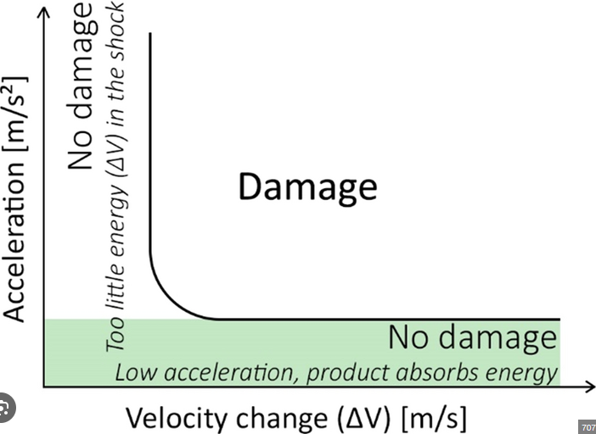

By plotting the measured shock pulse data on the damage boundary curve, it is possible to assess whether the recorded acceleration levels exceed the threshold where damage is likely to occur. If the data points fall above the damage boundary curve, it indicates that the shock experienced during the drop may have caused damage to the packaging or product. On the other hand, if the data points fall below the curve, the shock is less likely to have caused significant damage.

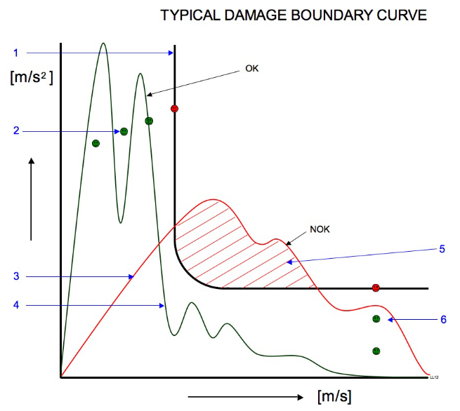

Analyzing the shock pulse in this way with the aid of the damage boundary curve allows for a quantitative assessment of the impact forces and helps in determining the potential risk of damage to the packaging or product. This analysis is crucial for evaluating the effectiveness of the packaging design in protecting the product from shocks during handling, transportation, and storage in the supply chain.

1. **Briefly describe the factors which will impact on the frequency and intensity of shock which a pack will experience in distribution.**

# (4 marks)

Based on the information provided in the search results, the key factors that impact the frequency and intensity of shock experienced by a package during distribution are:

1. **Distribution Environment**:

- The physical distribution environment, including the mode of transportation (e.g., truck, rail, air, sea), can subject the package to different types and levels of shock and vibration.

- Packages transported by air or sea may experience more intense but less frequent shocks compared to those transported by truck or rail.

2. **Handling Practices**:

- The handling practices during loading, unloading, and storage can significantly affect the shock experienced by the package.

- Rough handling, such as dropping or throwing packages, can result in high-intensity shocks.

- Improper stacking or support of packages can lead to compression and racking forces, causing shocks.

3. **Package Design and Construction**:

- The design and materials used in the package can influence its ability to withstand and absorb shocks.

- Packages with rigid, brittle materials may be more susceptible to damage from shocks compared to those with more resilient, cushioning materials.

- The size, shape, and weight of the package can also affect its response to shocks during distribution.

4. **Unit Load Configuration**:

- The way the packages are assembled into a unit load, such as on a pallet or in a container, can impact the transmission of shocks.

- Poorly secured or unstable unit loads are more likely to experience higher-intensity shocks.

- The use of dunnage, cushioning, and other load stabilization methods can help mitigate the effects of shocks.

5. **Transportation Conditions**:

- Factors like road conditions, vehicle suspension, and driving practices can contribute to the frequency and intensity of shocks experienced by packages during transportation.

- Packages transported over rough terrain or at high speeds are more likely to encounter more frequent and intense shocks.

In summary, the distribution environment, handling practices, package design, unit load configuration, and transportation conditions are the key factors that can influence the frequency and intensity of shocks experienced by a package during the distribution process.

Question 4